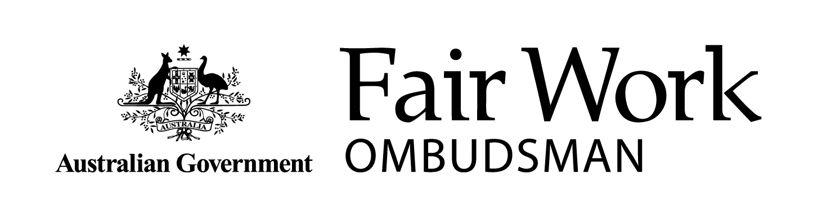Corporate Plan 2020-21

Fair Work Ombudsman and

Registered Organisations Commission Entity

Corporate Plan 2020-21 – 2023-24

August 2020

© Commonwealth of Australia 2020

| **Table of Contents** |  |
| --- | --- |
| Statement of Preparation | 3 |
| **The Fair Work** **Ombudsman** | 4 |
| Our purpose | 5 |
| Environment | 6 |
| Our priorities | 7 |
| Key activities | 10 |
| Operating context | 13 |
| Performance | 17 |
| **Registered Organisations Commission** | 20 |
| Our purpose | 21 |
| Environment | 21 |
| Key activities | 22 |
| Operating context | 23 |
| Performance | 25 |
| Appendix – requirements checklist | 26 |

# Statement of Preparation

The Office of the Fair Work Ombudsman (FWO) and the Registered Organisations Commission (ROC) are separate regulatory bodies that together form a combined entity under the Public Governance, Performance and Accountability Act 2013 (Cth) (PGPA Act).

This Corporate Plan is the key planning document for the Fair Work Ombudsman and Registered Organisations Commission Entity (the Entity) and outlines the strategic plans for the FWO and the ROC.

As the accountable authority of the Entity, I present the 2020-21 Fair Work Ombudsman and Registered Organisations Commission Entity Corporate Plan for the four-year period of 2020-21 to 2023-24 as required under paragraph 35(1)(b) of the PGPA Act.

Sandra Parker PSM

Fair Work Ombudsman

August 2020

# The Fair Work Ombudsman

## Foreword from Sandra Parker PSM, Fair Work Ombudsman

The unprecedented global challenges arising from the COVID-19 pandemic are significantly affecting the Australian economy, workplaces, workers and the broader community. These profound effects will likely continue for some time.

Demand for our services has increased significantly. As we work through the immediate and ongoing impacts of the pandemic, it is crucial that we continue to support the community by providing Australian workplaces with up-to-date, reliable, and timely information and services.

To fulfil this purpose, we will continue to focus on providing advice, education and guidance through our frontline services. We will take a customer-first approach to service-delivery that includes empowering parties to discuss workplace issues and agree on workable solutions that suit their circumstances while complying with workplace laws.

We will promote compliance by undertaking a range of activities to address the exploitation of vulnerable workers and, in our other priority areas of focus. These activities will be undertaken in line with our public [Compliance and Enforcement Policy](https://www.fairwork.gov.au/about-us/our-policies). In particular, we will focus on businesses that repeatedly breach workplace laws or do not comply with their obligations under the JobKeeper scheme. We will also focus on the increasing challenge of non compliance from large corporate entitites.

Now more than ever, the Australian Government must deliver a coordinated service to the community. We will work across government, delivering joined-up services and sharing information to support the community.

Our highly engaged staff are committed to service. We will continue to invest in our people, protect their health and wellbeing, and enhance our capability to deliver on our priorities. This commitment includes upgrading our information technology systems so our staff have the best tools at their disposal to provide reliable advice and assistance.

This plan outlines the key strategic priorities and activities for the FWO in the 2020-21 financial year and the projected outlook for the next four years until 2023-24.

We will review our approach in December 2020 to ensure that our focus remains relevant in this rapidly changing environment.

# Our purpose

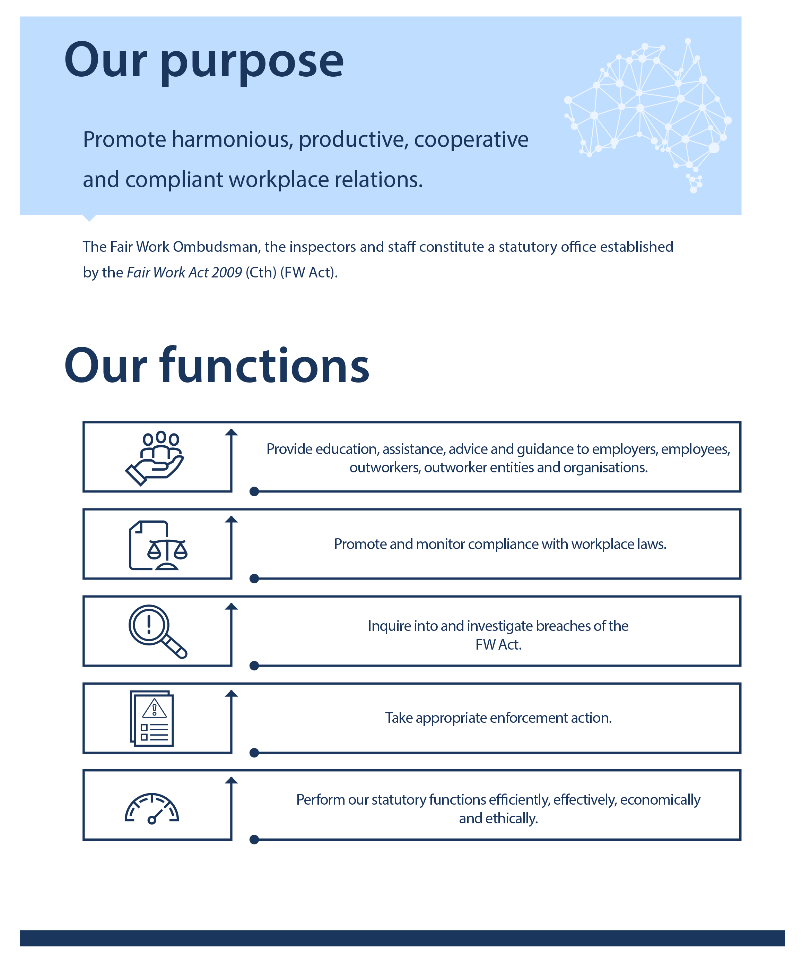

# Environment

The unprecedented domestic and global health, economic and social impacts of the COVID-19 pandemic will be felt for some time. The industries and sectors affected by these changes are growing.

The Australian Government introduced the JobKeeper wage subsidy to assist employers significantly affected by COVID-19 to retain staff during the downturn caused by the pandemic and to support business recovery as conditions improve.

Key stakeholders from employer, industry and employee bodies are meeting with government to discuss how our industrial relations system can best support the Australian economy to recover. Reform committees will consider potential changes to:

* award simplification
* enterprise agreement making
* casual and fixed term employees
* compliance and enforcement
* greenfields agreements for new businesses, activities, projects or undertakings.

We will prepare for any resulting changes arising from this reform process.

The Australian community continues to need reliable information to inform their decision-making and we expect a further increase in demand for our advice and assistance. We will support employers and employees to transition out of the JobKeeper scheme by providing easily accessible education, advice, assistance and guidance on their workplace obligations and entitlements.

Our decision-making and priority planning is informed by analysis of the impact of COVID-19 on industries and vulnerable cohorts within the community. In order to maintain the integrity and to support the purpose of the JobKeeper scheme, it is vital that we take a coordinated, proportionate and risk-based approach to our regulatory functions. We will consider the:

* broader economic context and the impact on business operations
* need to ensure vulnerable workers are protected from workplace exploitation.

We must continue to evolve how we provide our services in response to changes in the types of employers and employees who approach us for assistance. In the past, the demand for our services typically came from award-reliant sectors and industries, and often from small to medium enterprises. More recently, we have identified an increase in the number of large corporate entities reporting large and complex underpayments. These reports can affect thousands of employees over significant periods and can involve contraventions of multiple instruments. Investigating such complex underpayments can require significant resourcing. We expect this trend to continue over the four-year outlook of this plan.

Australian workplaces are changing, as are the community’s expectations of its regulators with a greater community awareness of the need to uphold standards across the whole labour market and a public focus on the role and outcomes achieved by regulators. The role of technology in providing reliable information and advice, delivering education and ensuring compliance is becoming increasingly important.

Further, the focus on all regulators arising from the recommendations from the Royal Commission into Misconduct in the Banking, Superannuation and Financial Services Industry and the Migrant Workers’ Taskforce gave us a valuable opportunity to further refine our compliance and enforcement priorities and posture.

To continue to deliver our core business and services in this rapidly changing environment, we have structured our business around our core functions of:

* Compliance and Enforcement
* Policy and Communication
* Legal
* Corporate.

Our governance framework and co-ordinated approach to planning further assists us to be responsive to changes in our operating environment. In particular, we take a coordinated approach to planning, centred on the establishment of priorities to maximise our reach and impact.

In 2020-21, our planning approach has been adapted to reflect the challenges presented by COVID-19 on our operating environment. Given the pace of change, we will review our approach to planning in December 2020 and make any necessary revisions to our Corporate Plan given its four year projected outlook. We also remain committed to regularly reviewing our compliance and enforcement approach to ensure we best support the needs of the Australian community.

# Our priorities

To deliver on our Purpose and respond to the challenges in our operating environment, we will continue to focus on our core functions whilst remaining agile to the immerging needs of the Australian community. The development of annual compliance and enforcement priorities ensures that the FWO is responsive, and that the community remains informed about our areas of focus and priority.

We will continue to allocate our resources to prioritise:

* groups within the community that need the most help to understand and apply workplace laws
* systemic and serious non-compliance in the areas we have identified as our highest priorities.

Our annual compliance and enforcement priorities for 2020-21 are representative of the current environment, including the impacts of the COVID-19 pandemic and the measures put in place to control it. We recognise that the effects are broad, spanning those directly impacted such as hospitality businesses through to sectors where the negative impact was unexpected, such as the allied health professions.

We anticipate the direct economic effects on employment in Australia are likely to be significant and persist for some time. In addition, we will need to respond to potential industrial relations reform and policy changes. In this context, we have considered our priorities and approach to ensure we are exercising our statutory functions in the most effective and efficient way.

**Our 2020-21 priority sectors, issues and approach are:**

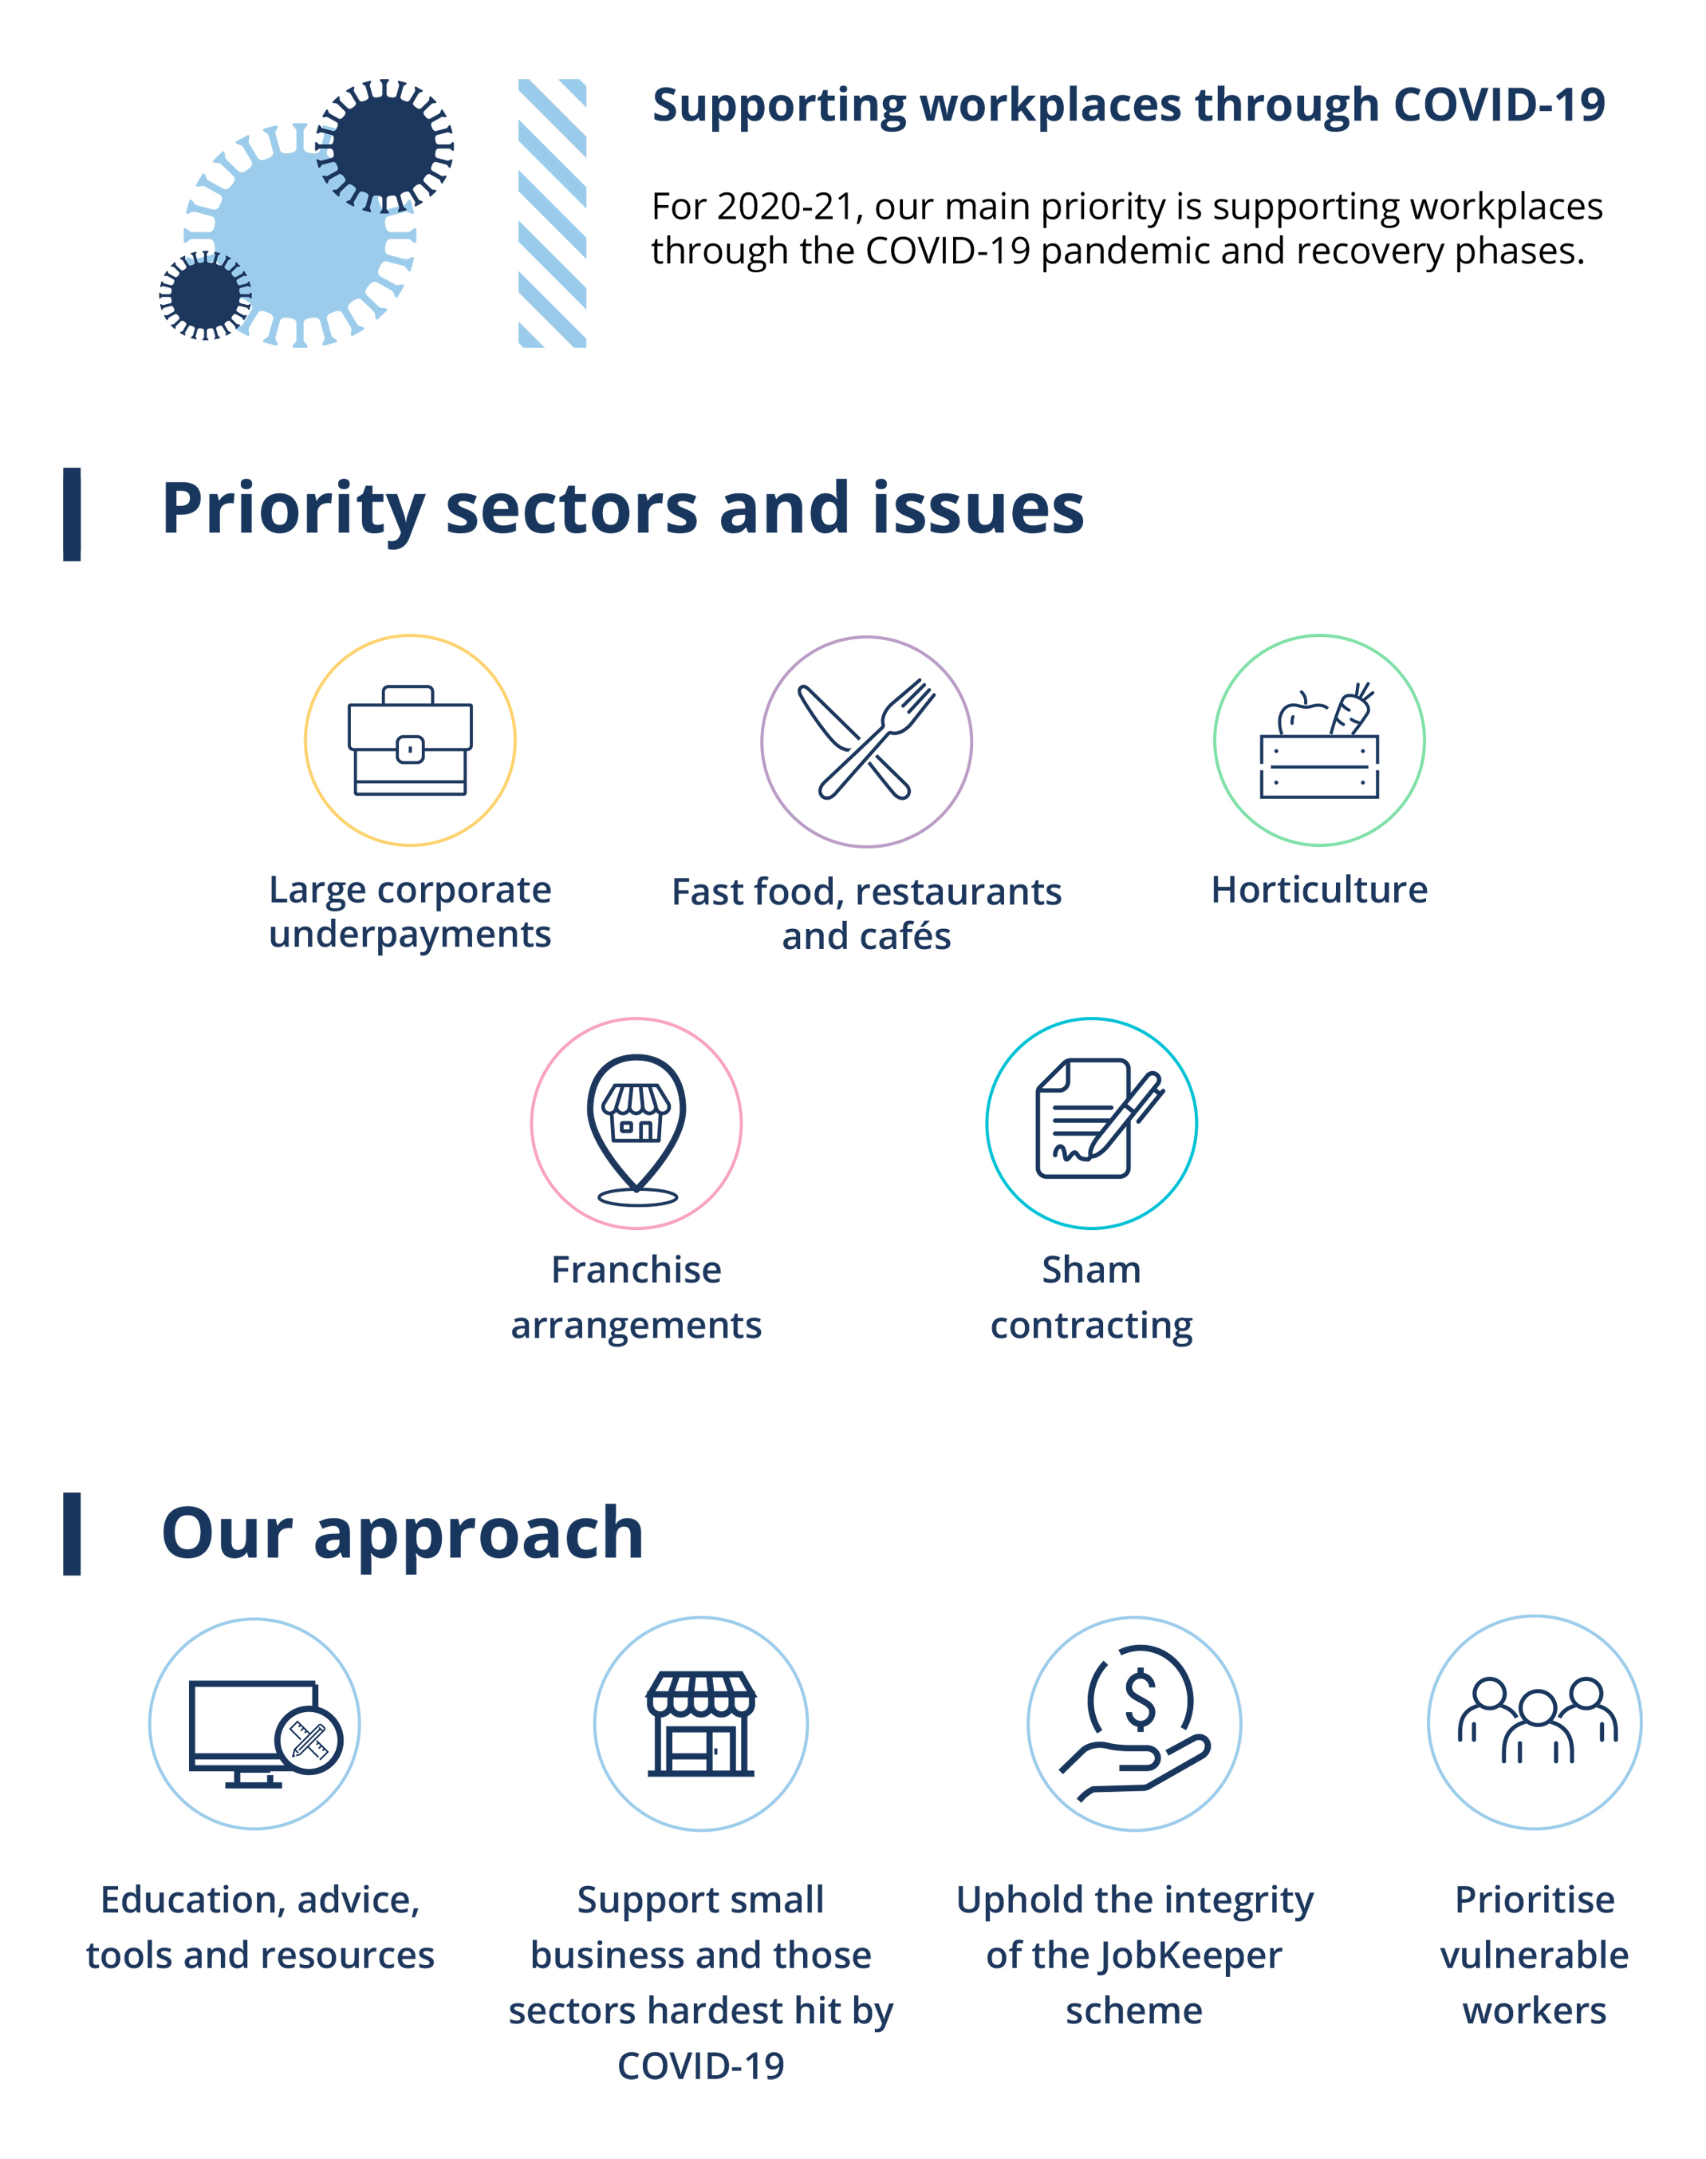

# Key activities

## Provide education, assistance, advice and guidance to employers, employees, outworkers, outworker entities and organisations

|  |
| --- |
| We aim to make compliance easier by providing information, resources and advice to employers, employees and other workplace participants, in the time and format they need. This includes delivering tailored and in-language information and education solutions to priority industries and vulnerable cohorts that make it easier to understand workplace rights and obligations.  To assist the community through the challenges of the pandemic, we will maintain a dedicated hotline and sub-site on fairwork.gov.au providing workplace relations information addressing COVID-19 issues for as long as such dedicated resources are required. Our pilot Workplace Legal Advice Panel will provide eligible employers with access to free legal advice to assist them in responding and recovering from the impacts of the COVID-19 pandemic.  We will continue to promote compliance with workplace laws by providing information, resources and advice to employers, employees and other workplace participants through our various advice channels, including our:   * Fair Work Infoline * website, [www.fairwork.gov.au](http://www.fairwork.gov.au) * online tools and resources, such as our Pay and Conditions Tool (PACT) * online portal (My account) * Record My Hours app * Anonymous Report tool * free online learning resources * social media content and responses.   Over the four-year outlook of this plan, we will regularly review our educational and advisory activities to enhance our service offerings in response to knowledge and skill gaps we have identified in the workplace community. This may include broadening our tailored and in-language service offerings and influencing workplace behaviour by using behaviourally informed approaches to encourage compliant workplace relations.    Informed by research and experience, we will design and implement a new Small Business Strategy to support small businesses through the economic challenges ahead and make it easier for them to comply with their obligations. |

## Promote and monitor compliance with workplace laws

|  |
| --- |
| We are committed to taking a risk-based and proportionate approach to compliance and enforcement that considers a range of challenges experienced by the community. We recognise and acknowledge the pressures that the COVID-19 pandemic is placing on businesses. However, our role as Australia’s workplace relations regulator also requires us to continue our compliance and enforcement efforts. Our approach will continue to be informed by evidence, including available data (such as anonymous reports) and undertaking targeted research and analysis.  Our approach to promoting compliance will reflect our continued effort to reduce the exploitation of vulnerable workers and working with high-risk industries to promote and monitor compliance. Over the four-year period we will promote compliance and enforcement outcomes to deliver a strong deterrence to those who deliberately flout their obligations.  We must seek to uphold the integrity of the workplace relations system and, in particular, measures introduced to support the economy such as JobKeeper.  We will continue to collaborate across government to focus our efforts in a coordinated way. We will share information as appropriate and monitor trends to focus our efforts where they are most needed. This includes our role in supporting the integrity of the JobKeeper scheme. |

## Inquire into, and investigate, breaches of the Fair Work Act and take appropriate enforcement action

|  |
| --- |
| We will continue to:   * conduct investigations, audits and inquiries in priority areas * issue compliance notices where our inspectors have a reasonable belief that underpayments have occurred * take appropriate, risk-based and proportionate enforcement action in accordance with our [Compliance and Enforcement Policy](https://www.fairwork.gov.au/about-us/our-policies) * be intelligence led.   The impact of the COVID-19 pandemic is widespread. We recognise that continuity of business is a significant issue for employers and their employees.  Some of our priority sectors have been seriously impacted and are under considerable financial strain. This includes the fast food, restaurants and café and horticulture sectors. We will take into account these circumstances and seek to reduce the regulatory burden associated with proactive compliance in these sectors and those similarly impacted.  Where we have identified a matter of significant public interest or concern, we will take a risk-based and proportionate response, addressing behaviour that seeks to exploit the COVID-19 crisis to obtain benefits unlawfully or deliberately exploit workers. We will also continue to use compliance notices as an efficient means to resolve underpayments without significant business disruption.  We remain concerned about the significant number of instances of employees being systemically underpaid by some of Australia’s largest employers. Notwithstanding the impact of COVID-19, this remains a significant issue of public interest and concern. We will continue to focus on corporate sector compliance to ensure major entities are meeting their obligations under Australia’s workplace laws and have in place appropriate governance and systems to ensure their employees are paid correctly.  We will develop a comprehensive regulatory response to deal with corporate entities that self-report non-compliance. Litigation is always an option, provided this is in the public interest (including consideration of the strains placed on businesses by the COVID-19 pandemic). Enforceable undertakings will continue to be accepted in appropriate matters as a transparent and accountable means to rectify contraventions and implement systems designed to ensure future compliance. |

## Perform our statutory functions efficiently, effectively, economically and ethically

|  |
| --- |
| Over the next four years of this plan, we will continue to:   * act in accordance with our [Compliance and Enforcement Policy](https://www.fairwork.gov.au/ArticleDocuments/725/compliance-and-enforcement-policy.pdf.aspx) and Legal Services Directions 2017 * provide stewardship over Government resources in accordance with the PGPA Act framework * ensure our employees understand their rights and obligations and act in accordance with the Public Service Act 1999 * apply and monitor the Fraud Control Framework and integrity-related policies * promote and embed an effective risk culture and leverage governance frameworks to manage risk. |

# Operating context

## Capability

We have a highly engaged, professional and purpose-driven workforce with committed and capable leaders. We regularly monitor the health of our workforce and seek feedback on how we can improve performance and better support our people.

Our future workforce development initiatives will focus on how greater employee engagement, the changing role of managers and increased workplace flexibility will change the way we work. We will tailor our learning, technological and people solutions to the needs of our business. We also will continue to monitor high-level workforce trends and best-practice research to inform our work.

In the short term, we are committed to ensuring the health and safety of our workforce and maintaining business continuity of our operations and the broader Australian Public Service in light of the COVID-19 pandemic. This includes reflecting on the lessons we have learned from our initial business continuity response and incorporating these into our ongoing workforce initiatives. We are also creating opportunities for our staff to reflect on their experiences to generate learning and innovation. This will enable us to sustain a highly engaged workforce and increase our resilience to disruption.

We continue to prioritise staff wellbeing, development and engagement, using human centred design principles to design programs that work for our people. We believe good managers are a key workforce capability and are continuing to develop our managers with the Manager Academy program. Our ability to rapidly and effectively transition to wide scale work from home arrangements in response to the COVID-19 pandemic while dealing with an increase in service demand is in large part due to the quality of our managers.

In line with the observations in the Independent Review, [Our Public Service, Our Future](https://pmc.gov.au/sites/default/files/publications/independent-review-aps.pdf), we must make better use of digital technologies and data to deliver outstanding services.

Over the four-year projected outlook of this plan, we will implement our Information Technology Strategy and roadmap, which outlines our future direction and initiatives designed to achieve:

* strengthened digital governance
* capabilities aligned to seamless services built on trust
* the delivery of high-quality services and better use of data.

We will focus on our business priorities, making the best use of technology to support nimble, reliable and efficient responses to tactical and strategic challenges. Collaboration focused on solving problems to achieve the best outcomes will be critical to our success. Our governance framework supports us to meet the challenges in our operating environment by providing stewardship, oversight, transparency and accountability.

## Risk oversight and management

The Fair Work Ombudsman is committed to good governance. We recognise that we must actively identify, engage with and monitor risk, particularly in times of uncertainty to achieve our Purpose and meet our statutory obligations.

In 2020, we commenced work on a review of our risk management framework. This included identification of our contemporary strategic risks and the determination of risk appetite. This work remains ongoing and will further strengthen our risk management approach.

Our key risk is that we fail to deliver on our statutory Purpose to promote harmonious, productive, cooperative and compliant workplace relations resulting in the loss of confidence of the community, the Parliament and our other key stakeholders. To mitigate this risk, we ensure that we consistently apply and deliver services in accordance with our:

* Governance Framework
* [Compliance and Enforcement Policy](https://www.fairwork.gov.au/about-us/our-policies)
* [Customer Service Charter](https://www.fairwork.gov.au/about-us/our-purpose/our-commitment-to-you#statement), and
* integrity related policies and procedures.

We recognise the importance of our relationships with our stakeholders and seek to ensure that our interactions are consistent, meaningful, productive, and beneficial for everyone involved through the application of our [Stakeholder Engagement Strategy](https://www.fairwork.gov.au/about-us/our-policies).

We acknowledge that we operate in a rapidly changing environment. In order to keep pace we need to ensure that our systems, information technology infrastructure and the skills of our people continue to develop. To address this, we seek to develop end enhance our workforce, technology and system capabilities through the initiatives outlined above.

Uncertainty associated with the COVID-19 pandemic has heightened the risk of fraud and cyber-security related risks. We will continue to cooperate with our colleagues in other entities to manage this risk by sharing information, resources and intelligence. We are also reviewing our fraud related controls to manage this risk to the best of our ability and in line with the changing environment.

Our current governance arrangements support the effective identification, assessment and monitoring of risk, including through the Corporate Board, whose members include the Fair Work Ombudsman and Deputies. The Corporate Board has primary responsibility for monitoring strategic risks and is supported in this function by an Accountability Committee, Information Technology Committee and the Audit and Risk Committee. Changes in the Entity’s environment that result in heightened risk are monitored and managed through activity specific working groups that report to the Corporate Board.

Our newly established COVID-19 Taskforce has developed a detailed risk assessment arising from the COVID-19 pandemic and is actively involved in identifying controls and treatments, and monitoring their implementation.

Risks arising from our statutory powers and functions under the Fair Work Act are overseen by the Enforcement Board which ensures a risk based and proportionate approach is taken in respect to our compliance and enforcement functions. The Enforcement Board also leverages opportunities to enhance our impact by identifying our strategic priorities and determining that our research, educational and other activities align with these.

Over the four-year outlook of this plan, we will manage risks by reflecting on changes to our compliance and enforcement posture and our increased use of compliance notices as a mechanism to achieve outcomes. We must remain agile and responsive to changes in our operating environment, ensuring we can support potential legislative changes and other initiatives designed to enhance compliance, such as the implementation of a labour hire licensing scheme.

We are actively implementing our newly revised Business Continuity Management Framework to ensure we continue to manage the continuity of, not only our business, but that of the broader Australian Public Service. This involves the active consideration and management of COVID-19 risks and the implementation of controls and treatments designed to ensure the ongoing business continuity of our operations and the safety of our people and other assets.

Over the four-year projected outlook of this plan, we will continue to build and enhance our business continuity and risk management capabilities and our focus on continuous improvement by enhancing our understanding of how customers experience our services.  Our internal audit activities and our analysis of customer feedback is informed by looking for opportunities to improve, and to ensure accountability and transparency across our work.

## Cooperating with others to achieve our Purpose

We are most effective in achieving our Purpose when we collaborate with others.

We work with others to share information, ideas and deliver initiatives across the public service by participating in inter-departmental committees, including the COVID-19 JobKeeper Working Group and the Deregulation and Employing your First Person Taskforces.

We have established a COVID-19 Response Taskforce to support our obligations and manage risks associated with COVID-19 and JobKeeper.

We work with the Australian Taxation Office, the Fair Work Commission, the Attorney General’s Department, the Treasury and other government agencies to ensure a coordinated approach to providing assistance on the JobKeeper scheme. We share, receive and act on information and intelligence to maintain the effective operation and integrity of the scheme and to manage shared risk.

We work across government to facilitate the delivery of government programs, including working with the Departments of Education, Skills and Employment and Foreign Affairs and Trade to support the Seasonal Worker Programme and Pacific Labour Scheme.

We will partner with experts in behaviour change and education to ensure our education initiatives are credible and innovative, and to build our internal capabilities.

We also are committed to working with organisations, groups and private enterprises to further our Purpose, including:

* to deliver the COVID-19 Supplementing Industrial Relations Advice Services and the Community Engagement Grants Program
* facilitating the provision of accurate, useful and timely legal advice through the Pilot Workplace Legal Advice Panel
* using online engagement solutions.

We will continue to engage with industry bodies, particularly in industries with higher rates of non-compliance. Our work with the Cleaning Accountability Framework and Horticulture Industry Reference Group seeks to improve industry compliance with workplace laws, by developing accessible, reliable and tailored information and tools for industry supply chains.

We will also continue to look to share experiences, promote good practice and identify opportunities for further collaboration with our international counterparts, including through the Trans-Tasman Employment Regulators Forum.

# Performance

Performance measures inform the community on how we deliver on our Purpose and provide accountability to Parliament on the responsible and effective use of public resources. Our performance measures also assist our staff identify how their role supports us to achieve our Purpose.

In 2019, we worked with a consultant to review our performance measures to ensure alignment with our strategic direction, Purpose and priorities and to better demonstrate our overall performance by ensuring a balance of outcomes and service delivery.

Our performance measures for 2020-21, set out in the table below demonstrate our efforts to promote compliance with workplace laws by supporting the Australian community to understand and comply with their workplace relations obligations. In particular, our measures demonstrate:

* the quality of our advice and assistance services
* the effectiveness of our digital tools
* the appropriateness of our compliance and enforcement activities
* our commitment to working with our stakeholders to develop our priorities.

When reporting against our performance measures in 2020-21, we will use a combination of data, and satisfaction surveys to demonstrate how we achieved our Purpose of promoting harmonious, productive and compliant workplaces.

These performance measures are new. We are committed to maintaining appropriate measures that demonstrate our performance and effectiveness. Given the rapid rate of change arising in our operating environment due to COVID-19, we will review these measures and targets by identifying trends and conducting analysis as our approach matures. Any changes will be published in this plan.

| Performance measures relating to our activities in providing education, assistance, advice and guidance to employers, employees, outworkers, outworker entities and organisations | | | | | |
| --- | --- | --- | --- | --- | --- |
| **Performance measure** | **Measures and targets** | **2020-21** | **2021-22** | **2022-23** | **2023-24** |
| **KPI 1: FWO has a positive impact on harmonious, productive, cooperative and compliant workplace relations** | | | | | |
| FWO will undertake an annual survey to determine stakeholder satisfaction levels. Year-on-year results will be used to measure changes in stakeholder satisfaction. | Percentage of stakeholder responses demonstrating a rating of satisfied or better. | Greater than 75% | Greater than 75% | Greater than 75% | Greater than 75% |
| **KPI 2: FWO provides high quality of advice and assistance** | | | | | |
| FWO will undertake ongoing surveys to determine customer satisfaction levels. A sample of customers who have interacted with our advisers through the Fair Work Infoline will be asked to participate in the surveys. | Percentage of customer responses demonstrating a rating of satisfied or better. | Greater than 75% | Greater than 75% | Greater than 75% | Greater than 75% |
| **KPI 3: FWO’s digital tools are effective** | | | | | |
| The FWO will use a combination of quantitative data and customer surveys to:   * report on digital tool usage numbers and year on year changes * survey customers to determine percentage of digital tool users who report that tools improved their understanding of workplace rights and obligations. | Percentage of customer responses demonstrating a rating of satisfied or better. | Baseline to be established through a customer survey in 2020 | Target established following 2020-2021 analysis | Target established following 2020-2021 analysis | Target established following 2020-2021 analysis |

| Performance measures relating to our activities in promoting and monitoring compliance with workplace laws and inquiring into and investigating breaches of the Fair Work Act and taking appropriate enforcement action | | | | | |
| --- | --- | --- | --- | --- | --- |
| **Performance measure** | **Measures and targets** | **2020-21** | **2021-22** | **2022-23** | **2023-24** |
| **KPI 4: Requests for assistance involving a workplace dispute finalised in average of 30 days** | | | | | |
| The FWO will use quantitative data to determine the average number of days taken to finalise a requests for assistance involving a workplace dispute. | Average time taken. | Less than 30 days | Less than 30 days | Less than 30 days | Less than 30 days |
| **KPI 5. FWO takes appropriate enforcement action** | | | | | |
| The FWO will use a combination of quantitative data and case studies to demonstrate that we:   * apply a risk-based approach to enforcement action in accordance with FWO’s compliance and enforcement policy * develop annual strategic compliance and enforcement priorities to guide our approach. | Compliance Notices issued  Penalty Infringement Notices  Enforceable Undertakings entered into  Litigations filed  Annual strategic compliance and enforcement priorities developed and announced | 850  400  20  40 - 50  ✓ | 850  400  20  40 - 50  ✓ | 850  400  20  40 - 50  ✓ | 850  400  20  40 - 50  ✓ |

# Registered Organisations Commission

## Foreword from Mark Bielecki, Registered Organisations Commissioner

The Registered Organisations Commission (ROC) is the independent regulator of 102 federally registered employer and employee organisations. Our functions include promoting the efficient management of organisations, and high standards of accountability of organisations and their office holders to their members.

There are 59 employer associations and 42 unions and one enterprise association which are comprised of 344 reporting units across Australia. Registered organisations reported to the ROC that in the 2019-20 financial year, cumulatively they have more than two million members, control almost $3.2 billion in assets and collect an annual revenue of more than $1.6 billion.

The ROC seeks to encourage behaviours in registered organisations that see them consistently focussed on acting in the best interests of their members, ensuring members’ money is spent in a way that is transparent, properly authorised and which complies with their obligations under the Fair Work (Registered Organisations) Act 2009 (the RO Act) and their rules.

As well as helping registered organisations to comply with the RO Act, the ROC is committed to fostering cultures of good governance and financial transparency.

The ROC also monitors compliance and, where necessary, conducts inquiries, investigations and litigation regarding serious non-compliance.

The COVID-19 pandemic has presented significant challenges for registered organisations, their branches and their members. We are committed to working constructively and pragmatically with the organisations we regulate, mindful that they may have encountered difficulties in complying with some of their regulatory obligations due to the impact of COVID-19.

As an agile regulator, we have developed, and will continue to develop, resources to assist organisations with compliance in these unprecedented times. The ROC's agility allows it to be responsive to the shifting landscape, tailoring its approach in response to the operating environment of registered organisations and reprioritising its compliance focus, which will, as always, remain risk-based and proportionate. This plan outlines the ways the ROC plans to deliver its functions and priorities for the 2020-21 financial year, as well as over the next four years until 2023-24.

# Our Purpose

The ROC’s Purpose is to monitor acts and practices to ensure they comply with the provisions of the RO Act, encouraging high standards of accountability of federally registered organisations (and their office holders) to their members and providing for the democratic functioning and control of organisations.

## Our functions and priorities

We aim to be valued by the community for the way we regulate and foster the efficient management and accountability of registered organisations.

Our functions are to:

* educate, assist and regulate federally registered organisations
* promote effective governance and financial transparency
* investigate and take appropriate enforcement action.

We regulate organisations, including assessing their financial reports, annual returns and officer disclosure statements while at the same time making arrangements for the election of office holders. We also register auditors, approve financial governance training and administer the protected disclosure (whistleblower) provisions of the RO Act where eligible disclosers are encouraged to ‘speak up’ and voice their concerns as they relate to breaches of rules, policies and disclosable conduct.

While we have a corporate service relationship with the FWO, we are independent in the exercise of our discrete statutory powers and functions.

During the period covered by this plan, we expect to continue to deliver on our role, particularly seeking to further develop a culture of voluntary compliance in registered organisations, and increased standards of accountability by organisations and their officers. We take a forensic approach in conducting inquiries and investigations, based on evidence, and the use of proportionate and appropriate enforcement tools.

# Environment

The landscape that our key stakeholders are operating in during the COVID-19 pandemic is one of significant upheaval. As the situation remains uncertain in the medium-to-long term, the ROC will remain responsive to stakeholder needs and will continue to consult with registered organisations and their peak bodies to provide relevant assistance and appropriate regulation.

The ROC is headed by the Registered Organisations Commissioner, Mark Bielecki. The Commissioner is supported by a small number of staff employed by the FWO who operate under his direction. The ROC operates as part of the Commonwealth’s broader industrial relations regulatory framework.

# Key activities

## Proactively educating registered organisations about financial and other reporting responsibilities

We do this by:

* engaging with registered organisations and their peak bodies to provide informative and practical tools that assist registered organisations to comply with their statutory obligations
* increasing awareness of our role
* working cooperatively with registered auditors as key ‘gate-keepers’ to enhance compliance.

## Encouraging democratic control and improved financial and disclosure compliance practices

We do this by:

* supporting organisations through arranging elections
* administering a comprehensive protected disclosure (whistleblower) scheme
* the timely assessment and publication of financial reports, annual returns and other disclosure statements
* promoting participation in approved governance training.

## Undertaking inquiries and investigations into suspected contraventions

We do this with:

* a risk-based approach to what we will investigate
* an evidence-based approach to our decision-making
* a proportionate response to non-compliant behaviour and practices
* the aim of influencing office holders in registered organisations to act in good faith, with due care and diligence, and in the interests of their members.

# Operating context

## Capability

Our ability to effectively regulate and deliver successful outcomes for registered organisations, their members and the community is evident in all aspects of our operations. In order to remain agile and to meet stakeholder needs, including as a response to issues arising from the COVID-19 pandemic, we are further developing our people and their skill-sets, our knowledge-base and our systems infrastructure to enhance the way we support and regulate our key stakeholders.

For the period covered by this plan we will:

## Develop our people

We provide an environment where employees are well-supported, challenged and inspired to carry out their work in a collaborative manner. We are committed to attracting, retaining and rewarding the highest possible calibre of staff and further developing their skills and knowledge.

## Build a strong knowledge-base

We will continue to build structures to enable our staff to efficiently access important information so that they can address stakeholder needs, solve problems, gain insights and collaborate with colleagues.

## Establish robust systems infrastructure

We will continue to refine and enhance new systems we have invested in to manage our workflow – this includes building our reporting capability through our case management system.

## Risk oversight and management

During the 2019-20 year, the ROC has reviewed and updated its risk framework. This will continue and be finalised in the 2020-21 financial year. The risk framework review is to ensure the ROC examines all of its static and dynamic risks in order to allocate and deploy resources appropriately and to safeguard the ROC’s ability to assess all matters and applications that come into the organisation within our performance targets.

In the conduct of our work, we encounter a range of risks and challenges. We manage these by:

* applying a consistent approach across our work streams and integrating risk management across all our activities
* applying a governance model which focuses on leadership and accountability, enabling us to meet our obligations
* providing support and encouraging our staff to capitalise on opportunities by actively engaging with risk and challenge.

## Cooperating with others to achieve our Purpose

The Registered Organisations Commission strives to work harmoniously with its stakeholders to resolve issues smoothly and to provide advice, assistance and educational materials that are both timely and relevant. We do this to encourage democratic control and improved compliance practices within registered organisations.

We are focused on building relationships with registered organisations and their peak bodies. We consult with our stakeholders and gather feedback throughout the year, including via our Annual Education Survey, and use it to inform the development and updating of tools and resources we provide to assist organisations with their compliance obligations.

As a small agency, the ROC functions differently to many other regulators and is able to provide immediate, tailored, personalised assistance to its stakeholders who can consult with a subject matter expert for information and advice quickly and easily. Organisations are also provided with tailored reminders about compliance obligations before the obligation arises.

The ROC also tailors its communication methods to meet the diverse requirements of organisations.

During the COVID-19 pandemic we have responded to the needs of our stakeholders by developing a suite of resources to assist them with any obstacles to compliance they may have been experiencing as a result of social distancing and other restrictions.

# Performance

## Key Performance Indicators

The performance criteria for the ROC’s program to deliver on its outcome over the projected four-year period of this plan are as follows:

|  |  |  |  |  |
| --- | --- | --- | --- | --- |
| **Key Performance Indicators** | 2020-2021 | 2021-2022 | 2022-2023 | 2023-2024 |
| 95% of financial reports required to be lodged under the RO Act are assessed for compliance within 40 working days | ✓ | ✓ | ✓ | ✓ |
| 95% of annual returns required to be lodged under the RO Act are assessed for compliance within 40 working days | ✓ | ✓ | ✓ | ✓ |
| Upon lodgement of prescribed information for an election, 95% of lodgements are dealt with within 40 working days | ✓ | ✓ | ✓ | ✓ |
| Upon lodgement of an application for registration by an auditor, 95% of applications are dealt with within 40 working days | ✓ | ✓ | ✓ | ✓ |
| Multiple items of information to educate employee and employer registered organisations and their members are made available  We publish our National Education Strategy each year in June outlining the education activities and resources that will be developed and delivered in the next financial year. These resources are informed by our Annual Education Survey. We also gather feedback about our resources from our stakeholders via surveys at workshops and webinars, as well as via our website | ✓ | ✓ | ✓ | ✓ |
| Key: ✓ means the KPI applies in the relevant period | | | | |

# Appendix – requirements checklist

Table of Corporate Plan requirements for the Entity

|  |  |
| --- | --- |
| **Corporate Plan requirement** | **Pages** |
| **Fair Work Ombudsman and Registered Organisations Commission Entity** | |
| Statement of Preparation | 3 |
| **Fair Work Ombudsman** | |
| Purposes | 5 |
| Environment | 6 |
| Key activities | 10 |
| Operating context   * Capability * Risk oversight and management * Cooperation | 13 |
| Performance | 17 |
| **Registered Organisations Commission** | |
| Purposes | 21 |
| Environment | 21 |
| Key activities | 22 |
| Operating context   * Capability * Risk oversight and management * Cooperation | 23 |
| Performance | 25 |